**Full Stack Development with MERN**

**Project Documentation**

**1. Introduction**

**Project Title**: Online Complaint Registration and Management System

**Team ID :** LTVIP2025TMID32193

**Team Size :** 4

**Team Leader :** G Rachitha

**Team member :** Datla Deepthi

**Team member :** Gummadi Reshmee Deepika

**Team member :** Pavan Kumar Gulla

**2. Project Overview**

**Purpose:**

To provide a centralized online platform where users can submit complaints, track progress, interact with agents, and receive timely resolutions, improving transparency and efficiency in complaint management.

**Features:**

* User registration & authentication

* Complaint submission with attachments

* Real-time status tracking and notifications

* Agent and admin dashboards

* Chat interface between user and agent

* Complaint assignment & routing

* Security via authentication, authorization, and encryption

**3. Architecture**

**Frontend:**

Developed using React.js with Material UI and Bootstrap for a responsive user interface. Axios is used for API communication.

**Backend:**

Node.js with Express.js framework handles API routes, middleware, and server-side logic.

**Database:**

MongoDB is used for storing user profiles, complaints, chats, and assigned complaints. Mongoose ODM is used for schema management.

**4. Setup Instructions**

**Prerequisites:**

* Node.js and npm

* MongoDB Community Server

* Git

* Visual Studio Code

**Installation Steps:**

1. Clone the repository:

git clone https://github.com/ReshmeeDeepika/Complaint_Registration.git

2. Navigate to the project folder:

cd Complaint_Registration

3. Install dependencies:

cd frontend

npm install

cd ../backend

npm install

4. Set up environment variables (.env file) for database URI and JWT secrets.

**5. Folder Structure**

**Client (Frontend):**

* `components/` - Reusable UI components

* `pages/` - User, Admin, and Agent pages

* `services/` - Axios service files for API calls

**Server (Backend):**

* `routes/` - Express route handlers

* `models/` - Mongoose schemas

* `controllers/` - Business logic functions

* `middleware/` - Auth and error-handling middlewares

**6. Running the Application**

**Frontend:**

cd frontend

npm start

**Backend:**

cd backend

npm start

Application runs on `http://localhost:3000`.

**7. API Documentation**

Base URL:`http://localhost:5000/api`

* `POST /auth/register` - Register a new user

* `POST /auth/login` - Login and receive JWT

* `POST /complaints` - Submit a complaint

* `GET /complaints/:userId` - Fetch user's complaints

* `POST /assignments` - Assign complaint to agent

* `GET /messages/:complaintId` - Fetch chat messages

* `POST /messages` - Send chat message

**8. Authentication**

Method: JSON Web Tokens (JWT)

* Login: Returns JWT stored in localStorage

* Protected Routes: Middleware verifies JWT

* Roles: User, Agent, Admin

**9. User Interface**

**Screenshots**:

* Landing Page

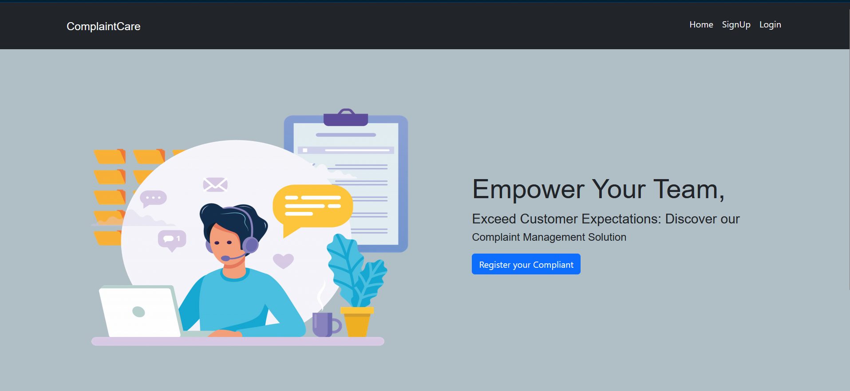

* Login & Registration Pages

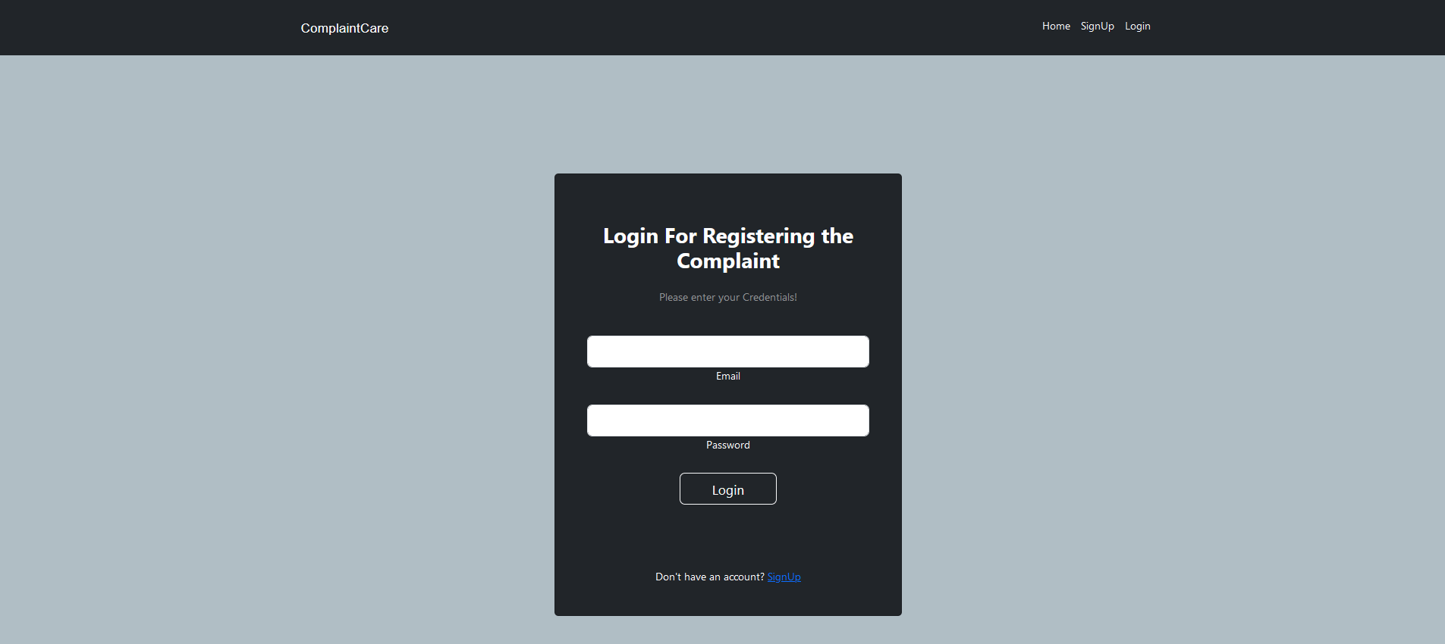

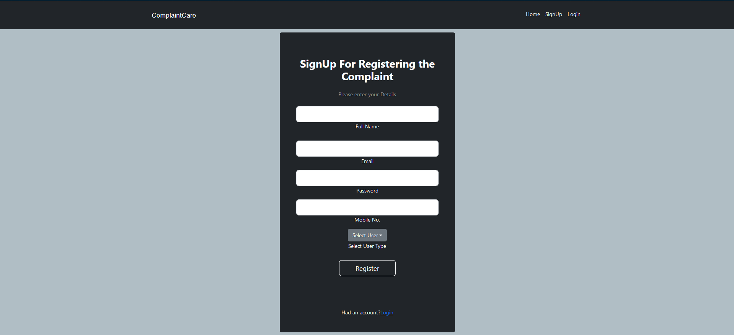

* Complaint Dashboard

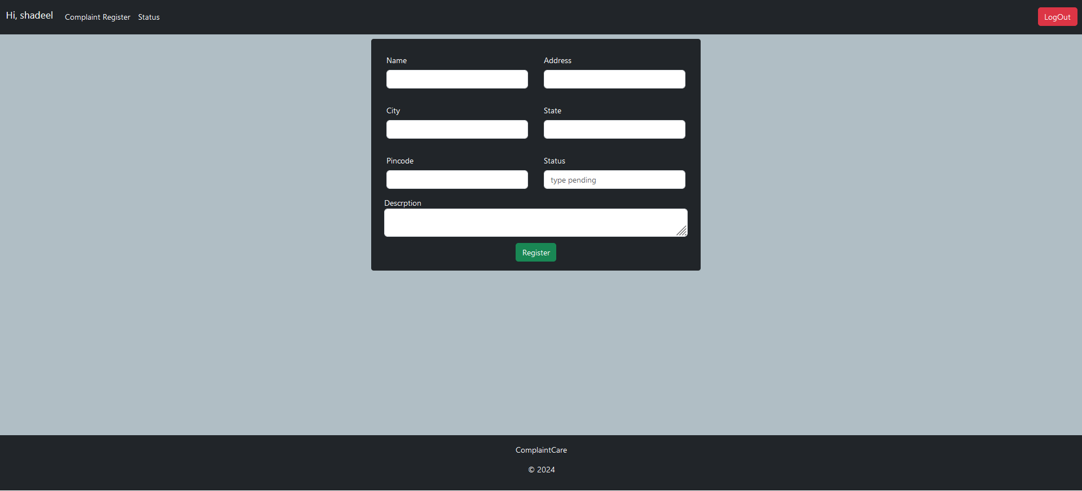

* Admin Panel

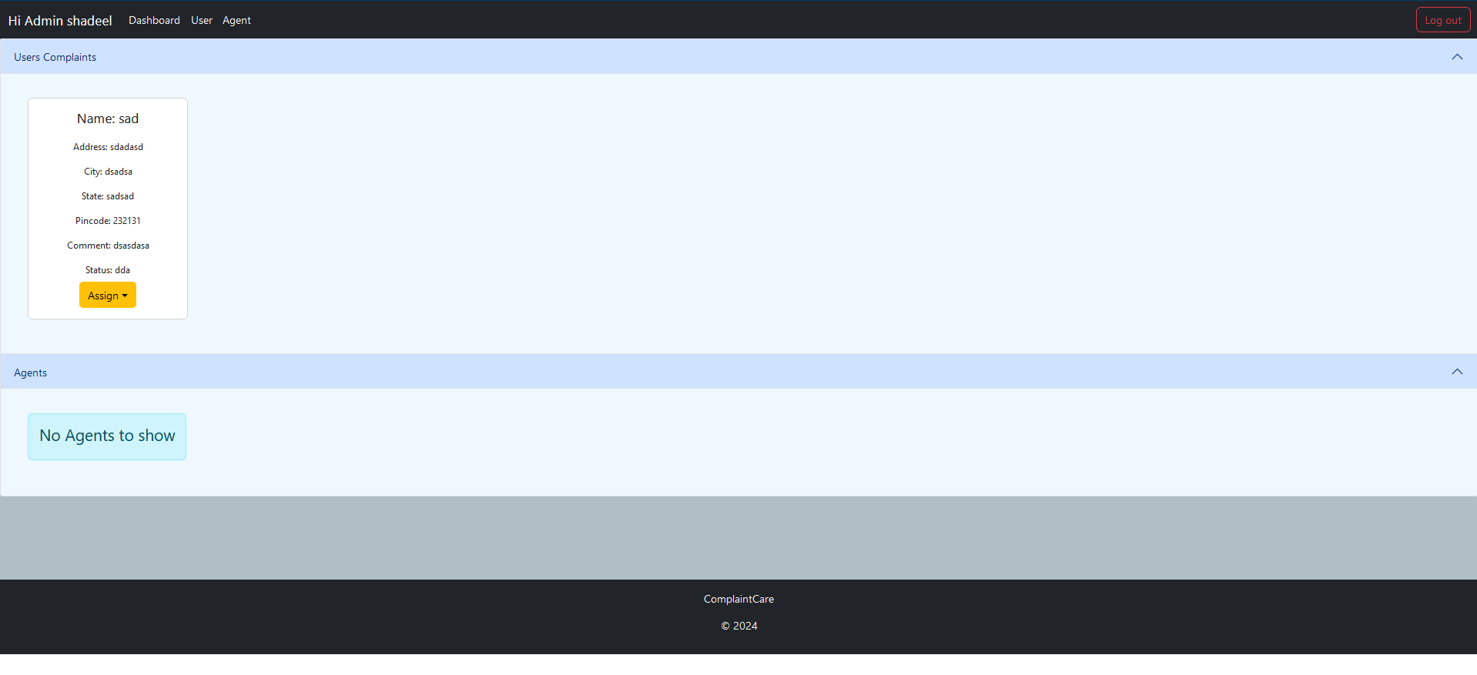

* Agent Dashboard

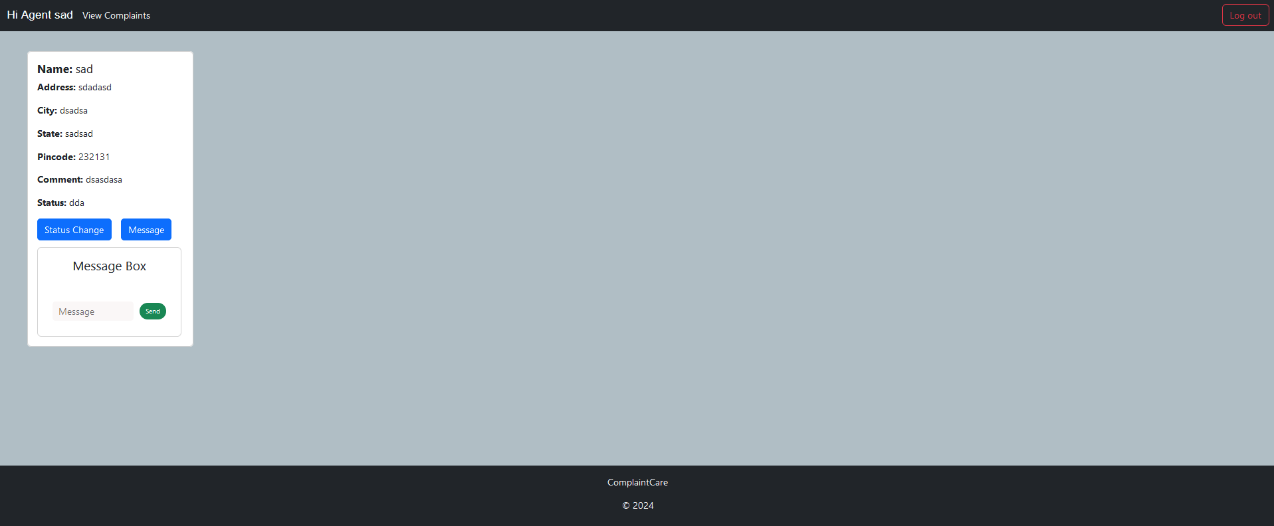

**10. Testing**

**Strategy**:

* Manual testing of features

* Postman for API endpoint validation

* Console logging for debugging

**Tools:**

* Postman, Browser DevTools, MongoDB Compass

**11. Demo**

* GitHub Repo:

(https://github.com/ReshmeeDeepika/Complaint_Registration.git)

**12. Known Issues**

* Limited input validation on complaint forms

* Lack of unit testing for backend logic

* Chat window does not auto-scroll

**13. Future Enhancements**

* Add file type validation for complaint attachments

* Add pagination and filtering to admin dashboard

* Enable push notifications

* Integrate email service for communication

* Enhance mobile responsiveness